Section I
Total Marks (75)

Part A
Total marks (15)
Attempt Questions 1-15
Allow about 30 minutes for this part

INSTRUCTIONS
Use the multiple choice answer sheet on page 6.
Select the alternative A, B, C or D that best answers the question. Fill in the response oval completely.

Sample 2+4= (A) 2 (B) 6 (C) 8 (D)9

A  B  C  D 

If you think you have made a mistake, put a cross through the incorrect answer and fill in the new answer.

A  B C  D 

If you change your mind and have crossed out what you consider to be the correct answer, then indicate this by writing the word correct and drawing an arrow as follows:

correct

A  B  C  D 

________________________________________________________________________________

1. Which of these substances is detectable using AAS?

(A) Scandium
(B) Sulfate
(C) Sulfur
(D) Sulfur dioxide

Outcome(s):H4
Ans : A

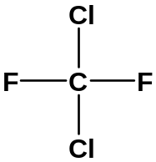2.

Which is the correct systematic name for the above structure?

(A) dichlorofluoromethane
(B) dichlorodifluoromethane
(C) 1,1–difluoro–1,1–dichloromethane
- 2,4–dichloro–1,3–difluoromethane

Outcome(s):H9
Ans : B

3. Fritz Haber and many other chemists worldwide were actively working to solve the problem
of making ammonia by direct synthesis. What was the reason for this great interest
ammonia?

(A) Ammonia was unsurpassed as a coolant in refrigerators.
(B) Ammonia was essential for making high explosives for World War II.
(C) Ammonia was a very effective cleaning agent, but too expensive for household use.
(D) Ammonia was a possible solution to a projected global problem of soil infertility.

Outcome(s):H4
Ans : D

4. Which metal ion cannot be identified by a flame test?

(A) Ba²⁺_{(aq)}
(B) Ca²⁺_{(aq)}
(C) Cu²⁺_{(aq)}
(D) Pb²⁺_{(aq)}

Outcome(s):H4
Ans : D

5. A fruit cannery factory discharges untreated wastes, consisting largely of rinse water and
fruit pulp, into a nearby stream. What effect will this have on the water?

(A) The level of dissolved oxygen will increase.
(B) Turbidity would decrease
(C) The biochemical oxygen demand will increase.
(D) The hardness of the water will increase.

Outcome(s):H4
Ans : C

6. Which oxide does not produce an acid in water?

(A) N₂O
(B) NO₂
(C) SO₂
(D) SO₃

Outcome(s):H5
Ans : A

- A certain solution has ten times more hydrogen ion than another solution of pH = 8. What is the pH of the more acidic solution?

(A) 0.8
(B) 4
(C) 7
(D) 9

Outcome(s):H13
Ans : D

- 10 mL of a 0.1 mol L⁻¹ hydrochloric acid solution is added to 20 mL of a 0.1 mol L⁻¹ nitric acid solution. What is the pH of the mixture?

(A) 1
(B) 0.5
(C) -0.5
(D) 2

Outcome(s):H13
Ans : A

- What volume of carbon dioxide (measured at 25 ⁰C& 100kPa) is formed from the reaction of .25.0 g calcium carbonate with excess hydrochloric acid?

(A) 24.79 L
(B) 3.1 L
(C) 12.4 L
(D) 6.2 L
Outcome(s):H10
Ans : D
- When carbon dioxide is dissolved in water the following equilibrium occurs:

CO₂(g) + H₂O(l) H₂CO₃(aq)

The process is exothermic. What happens to the solubility of carbon dioxide if the solution is
heated?

(A) increases
(B) decreases
(C) remains constant, solubility is only affected by pH
(D) increases then decreases slightly.

Outcome(s):H8
Ans : B

11. How is ethylene produced industrially?

(A) extracted from crude oil
(B) fractional distillation of crude oil
(C) cracking of the low molecular weight fraction of crude oil
(D) fermentation of glucose

Outcome(s):H13
Ans : C

12. Low density polyethylene is produced using an organic peroxide initiator.
Given below is a randomly numbered list of the steps involved in its production:

1. Monomer radicals react with doubly bonded carbon atom of another molecule
2. Free radical organic peroxide initiator react with the doubly bonded
carbon atom in a monomer
3. Organic peroxide splits to form free radical
4. Activated monomer radicals form
5. Chain growth stops if free radicals combine together
6. Chain builds and lengthen

Choose the correct sequence from among the choices given below
(A) 2 → 3 → 4 → 1 → 5 → 6
(B) 3 → 2 → 4 →1 → 6 →5
(C) 4 → 3 → 1 → 2 → 6 → 5
(D) 3 → 1→ 2 → 4 → 5 → 6

Outcome(s):H9, H13
Ans : B

13. Cellulose is a biopolymer composed of glucose units. Choose the glucose structure
below required to form a strand of cellulose with 6 glucose units:

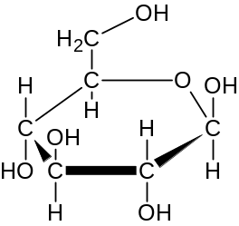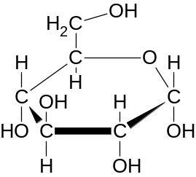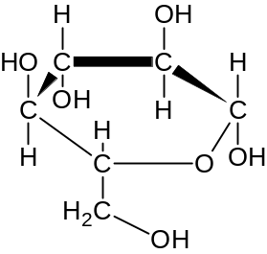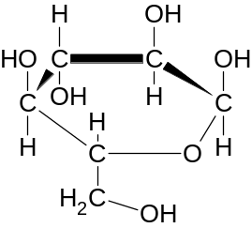

Structure 1 Structure 2 Structure 3 Structure 4

(A) 1, 4, 1, 4, 1, 4
(B) 2, 3, 2, 3, 2, 3
( C) 1, 3, 1, 3, 1, 3
(D) 2, 4, 2, 4, 2, 4

Outcome(s):H9, H10,H13
Ans : C

14. The molar heat of combustion of ethanol is 1364 kJ mol⁻¹. How much water at 20 ⁰C can be
heated to boiling (100⁰C) if 20.0 g of ethanol is completely combusted to carbon
dioxide and water.

(A) 2.02 g
(B) 2.02 kg
(C) 20.2 g
(D) 20.2 kg

Outcome(s):H9,H10,H7
Ans : B

15. A student undertook a first hand investigation to determine the relative reactivities
of cyclohexane and cyclohexene. Which conditions are appropriate for
this experiment?

Conditions | A | B | C | D
Reagent used | bromine water | chlorine gas | bromine water | ethanol
To increase validity | protect from light | control the temperature | repeat the experiment | repeat the experiment
Result observed | decolourised | odourless gas released | purple solution formed | sweet smelling gas released

Outcome(s):H6, H11,H12,H13,H14
Ans : A

Section A Mark -----/15

Multiple Choice Answer Sheet

1. A  B  C  D 

2. A  B  C  D 

3. A  B  C  D 

4. A  B  C  D 

5. A  B  C  D 

6. A  B  C  D 

7. A  B  C  D 

8. A  B  C  D 

9. A  B  C  D 

10. A  B  C  D 

11. A  B  C  D 

12. A  B  C  D 

13 A  B  C  D 

14. A  B  C  D 

15. A B  C  D 

JAMES RUSE AGRICULTURAL HIGH SCHOOL
2004 CHEMISTRY TRIAL HSC EXAM Student Number …………………………

Section I (continued)

Part B - 60 marks
Attempt Questions 16 -27
Allow about 1 hour and 45 minutes for this part

Answer the questions in the spaces provided
Show all relevant working in questions involving calculations

Question 16 (6 marks) MARKS

The aim of a Prac Test was the identification of four unknown solutions using four test
solutions. A student records these test results (R = reaction; NR = no reaction) …

 |  | Unknown Solutions
 |  | W | X | Y | Z
Test Solutions | HNO₃ | NR | NR | NR | R
Test Solutions | H₂SO₄ | R | R | NR | R*
Test Solutions | Ba(NO₃)₂ | NR | NR | R* | NR
Test Solutions | AgNO₃ | R | R* | NR | NR

The student was told that the unknowns were potassium sulfate, barium chloride,
sodium carbonate and calcium chloride.

(a) Identify the compounds which match–up with unknowns W, X, Y and Z. 3

Outcomes – H8, 10

Answers

W = calcium chloride
X = barium chloride 4 correct = 3 marks
Y = potassium sulfate 2 correct = 2 marks
Z = sodium carbonate 1 correct = 1 mark

(b) Write balanced chemical equations for the three asterisked reactions (R*) in the
table. . 3

Na₂CO₃ + H₂SO₄ → Na₂SO₄ + CO₂ _{(g)} + H₂O _{(l)} (1 mark)

K₂SO₄ + Ba(NO₃)₂ → BaSO₄ _{(s)} + 2KNO₃ (1 mark)

BaCl₂ + 2AgNO₃ → 2AgCl _{(s)} + Ba(NO₃)₂ (1 mark)

Question 17 (5 marks)

Outcomes – H4, 10

The National Australian Standard for sulfur in petrol is 500 ppm maximum.

(a) Calculate the mass of sulfur in one litre of petrol weighing 714 grams.
(Assume 500 ppm sulfur) 1

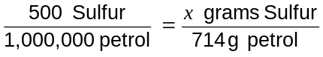 ; x = 0.357 g Sulfur (1 mark)

(b) Calculate the volume of sulfur dioxide produced by the complete combustion of
one litre of petrol at 100 kPa and 25°C. 2

moles of Sulfur = moles of SO₂ = m ÷ M = 0.357 g ÷ 32.07 g mol ^{–1} = 0.0111 mol
(1 mark)

volume of SO₂ = (n) (molar volume) = (0.0111 mol) (24.79 L mol ^{–1}) = 0.276 L (1 mark)

(c) Write a balanced chemical equation showing sulfur dioxide producing acid rain and
name the acid formed. 2

SO₂ _{(g)} + H₂O _{(l)} → H₂SO₃ _{(aq)} (1 mark)

Sulfurous acid (1 mark)

Question 18 (6 marks)

A Year 9 student does a research project testing the BOD of a polluted stream near his home.
He writes this entry in his science journal…

I got a bucketful of stream water and carried it home. It looked a bit murky so I decided
to filter it through a plastic funnel using paper towel for filter paper. It worked well and
cleared up the water.

I measured out exactly one litre of stream water and poured it into a 2 litre beaker.
I then measured the dissolved oxygen using a borrowed oxygen–sensitive electrode and
recorded the reading.

I then placed the beaker on a shelf underneath the awning on the back veranda..
A week later I measured the dissolved oxygen again and recorded the reading.

(a) The procedural errors made by the student will greatly affect the validity
of the BOD result. Identify two errors made and provide the correct
procedures he should have followed. 5

Outcomes – H12

Answers

(a)
Student’s Error | Correct Procedure
Filtered water sample | BOD samples should never be filtered.
Sample uncapped | BOD samples must be capped.
Sample exposed to light | BOD samples must be stored in the dark
Sample stored at unregulated temperature | BOD samples must be stored at 20°C
Sample stored for one week | BOD samples must be stored for 5 days

► Two errors & corrections @ 1 mark = 2 marks

(b) The student suspects that the polluted stream is subject to eutrophication.
Identify two (2) chemical species which he could test for as proof of eutrophication. 2

Nitrogen (nitrate) and phosphorus (phosphate)

(c) The student decides to test the stream water for total dissolved solids without
using a TDS meter. Describe a simple test procedure he should follow and the data he
should collect and record 2

Procedure: Filter the water sample and slowly evaporate a known sample volume or mass.
(1 mark) ► Must include filtration.

Data: Collect and record the water sample’s original volume (or mass) and the mass of the dried residue after evaporation. (1 mark)

(d) High tech microscopic membrane filters are a means of cleaning up some
polluted water.

(i) Identify the composition of the membranes, i.e. what are they made of? 1

The membranes are made of polymers.

(ii) Membrane filters can capture germs but not heavy metal ions.
Describe the physical basis of how these filters work. 1

The physical basis of membrane filtration is the microscopic pore structure
MARKS

Question 19 (3 marks)
Outcome: H10

In a titration to find the concentration of sulfuric acid solution, 28.6 mL of
0.176 mol L⁻¹ sodium hydroxide solution was required to neutralise 25.0 mL of
sulfuric acid solution. Calculate the concentration of the sulfuric acid solution in
mol L⁻¹. 3

.H₂SO₄ (aq) + 2 NaOH (aq) → Na₂SO₄(aq) + 2 H₂O (l)

No. of mole NaOH = 0.0286 x 0.176 = 5.03 x 10⁻³
No. of mole H₂SO₄ = ½ x 5.03 x 10⁻³ = 2.52 x 10⁻³

[H₂SO₄] = 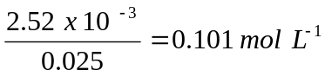

Question 20 (3 marks)
Outcome :H9

(a) Describe using a balanced chemical equation the formation of an ester from the reaction
of C₃H₇COOH (l) with C₂H₅OH (l) 2

conc.
C₃H₇COOH (l) + C₂H₅OH (l) H₂O(l) + C₂H₅OOCC₃H₇(l)
H₂SO₄

Criterion/criteria | Mark
Balanced equation | 1
Conditions (double arrow), conc H₂SO₄ as catalyst | 1

(b) Name the ester. 1

ethyl butanoate

Question 21 (4 marks)
Outcome: H3

Identify examples of naturally occurring acid and base.. In the table below record their names
and their chemical formulae

ACID | Chemical Formula
.hydrochloric | HCl
BASE | Chemical Formula
. sodium hydrogen carbonate | NaHCO₃

Student Number …………………………

MARKS
Question 22 (3 marks)

Outcome:H8

Some commercial baking powders use sodium pyrophosphate (Na₂H₂P₂O₇) and sodium
hydrogen carbonate (NaHCO₃) to make cakes rise when cooked.

The reaction that occurs can be described by the following equation (states excluded)

NaHCO₃ + Na₂H₂P₂O₇ Na₃HP₂O₇ + H₂O + CO₂

(a) Write the net ionic equation for this reaction, including states. 1

HCO₃⁻(aq) + H₂P₂O₇ ²⁻(aq) HP₂O₇³⁻(aq) + H₂O(l) + CO₂(g)

(b) From this net ionic equation, write the formula for a species behaving as a
Bronsted-Lowry acid. 1

. H₂P₂O₇ ²⁻(aq)

(c)What is the conjugate base of the acid species identified in (b)? 1

HP₂O₇³⁻(aq)

Question 23 (7 marks)

Outcomes: H12,H13

An investigation to determine the concentration of acetic acid in two brands of domestic
vinegar was carried out. Standard sodium hydroxide solution was used to titrate equal volumes
of Brand A and Brand B. The results of these titrations are shown below.

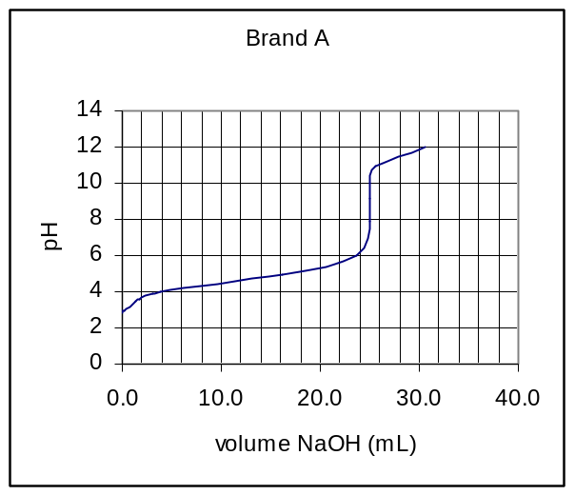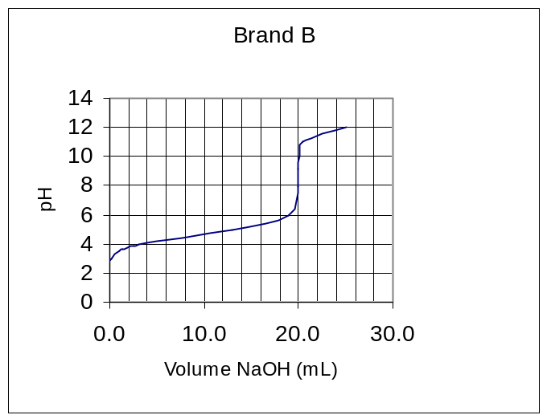

(a) Explain the procedure that can generate these titration curves 3

These curves could be obtained by adding the sodium hydroxide solution (contained in
a burette) incrementally (eg. 1 mL increments) to the vinegar solution contained in a
beaker. A magnetic stirrer mixes the acid and base solutions. The beaker
contains a pH probe attached to a datalogger* which measures pH. The data logger is
connected to a computer which displays the titration curve. The pH probe may also be
connected to a pH meter and measurements of pH are recorded after each small addition of the base (eg., after 1 mL) A graph is drawn from these measurements.

(b) Identify the solution used to rinse the pipette before its final use 1

vinegar solution

(c) Which brand (A or B) had the higher concentration of acetic acid? Give a reason. 1

Brand A had the higher concentration of acetic acid as it required a greater volume of
NaOH solution to react with the same volume of vinegar

(d) ) Is the salt produced by this reaction acidic, basic or neutral? Write a net ionic equation
to support your answer. 2

basic salt

CH₃COO⁻(aq) + H₂O (l) → CH₃COOH (aq) + OH⁻(aq)
Student Number …………………………

MARKS
Question 24 (5 marks)
Outcome(s): H13, H5 H1, H3,H4,H9
(a) Examine the following flowchart showing the conversion of cellulose to ethylene .
cellulose

Process 1
glucose

Process 2

Substance 3

Process 3
ethylene

(i) Name substance 3………………ethanol………………………………………. 1

(ii) Write a balanced formula equation for Process 2.

C₆H₁₂O₆(aq) yeast enzymes 2 CO₂(g) + 2 C₂H₅OH(aq) 1

(iii) Write a balanced formula equation , including the catalyst for Process 3

C₂H₅OH(l) conc.H₂SO₄ C₂H₄ (g) + H₂O(l) 1

(b) Discuss the potential of cellulose as a raw material for building petrochemicals in
terms of its structure and in terms of the energy requirement of the process
detailed in (a) above 2
Sample Answer:
Cellulose contains the basic carbon-chain structures needed to build
petrochemicals The above scheme is a multi-step process making use of readily
available cellulose in the form of biomass . However, each step of the production requires
large amount of energy especially the separation of the ethanol from the fermentation
mixture. At the present time therefore, while fossil fuels are still relatively cheaply available,
the use of cellulose may not be viable yet.

Criterion/criteria | Mark
discussion on the structure of cellulose being suitable as starting material | 1
energy requirement of process | 1

Question 25 (2 marks)

Outcomes: H13
Write the details on the property and use of the common polymer, poly(vinyl chloride). 3

Polymer name (systematic) | Common monomer name | Polymer property | Polymer use related to property
poly(chloroethene) or  poly(ethenylchloride) | vinyl chloride | does not conduct electricity | used as an electrical insulator

Criterion/criteria | Mark
Polymer name | 1
Polymer property and use | 1

Question 26 (3 marks)

Outcome(s): H13, H6
Compare a named transuranic element and a named commercial radioisotope in terms of their
production 4

Transuranic elements such as neptunium-239. is produced by bombarding uranium-238 with neutrons produced by the nuclear fission of uranium-235. Final isotopes produced have relatively long half-lives. Similarly, commercial radioisotopes are produced by the bombardment of elements with neutrons from a uranium fission reactor or by using a cyclotron particle accelerator producing isotopes with relatively shorter half-lives., for example, cobalt-60, an isotope used in the treatment of cancer, is produced by the neutron bombardment of cobalt-59.
Criterion/criteria | Mark
Production of transuranic elements and example | 2
Production of commercial radioisotope and example | 2

Question 27 (9 marks)
Outcome(s): H13, H8,H16
(a)Draw a simple, neat well-labelled diagram of a dry cell OR a lead-acid cell. In your
diagram, you should indicate : 4
(i) the direction of flow of electrons
(ii) the cathode, the anode and the electrolyte

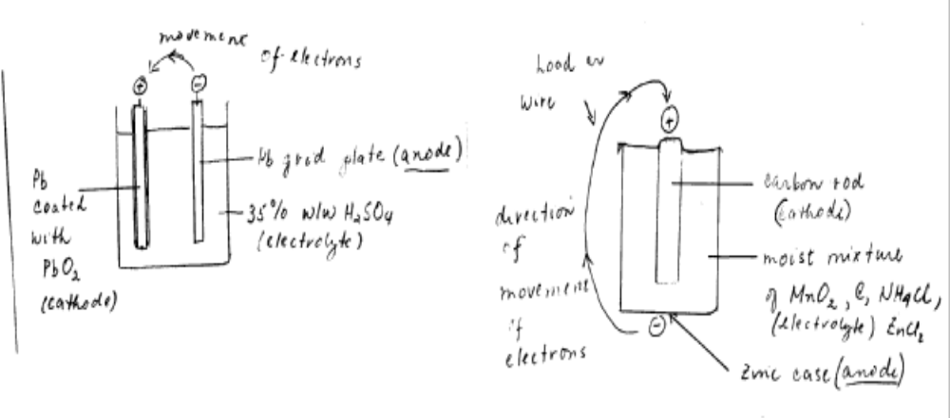

MARKS

(b) Evaluate the dry cell or the lead acid cell in comparison to ONE of the following:
- button cell
- fuel cell
- vanadium redox cell
- lithium cell
- liquid junction photovoltaic device
in terms of chemistry and environmental impact 5

Answer
Battery | Chemistry | Impact on the environment
lead acid battery | Anode:  Pb(s) + SO₄²⁻ → PbSO₄(s) + 2e⁻  Cathode:  PbO₂(s) + 2e⁻ + 4 H⁺ + SO₄²⁻ → PbSO₄(s) + 2 H₂O(l) | acid waste and lead metal can pollute the environment, lead however, can be recycled
Vanadium redox cell | Anode:  V²⁺ → V³⁺ + e  Cathode:  VO2+ + 2 H+ + e- → VO2+ + H2O | may be used to store other forms of energy, vanadium is safe and non-polluting since the vanadium solution may be recycled indefinitely
The lead-acid battery has a solid oxidant (PbO₂) , a solid reductant (Pb) with a common solid redox product, PbSO₄ which adheres to the electrode. This makes the lead-acid battery rechargeable by simply applying the appropriate potential on the electrodes. The vanadium redox battery is also rechargeable simply by replenishing the anolyte (V⁺²) solutions and the catholyte ( VO₂⁺) solutions. It is important that the oxidant and the reductant do not mix. This necessitates a separate compartment for each solutions, making it less compact than the lead acid battery. It also requires a pump to circulate the solutions.
Overall, the lead storage battery delivers the required voltage but its use is disadvantaged by the lead which can pollute the environment. On the other hand, the vanadium storage battery is safe and environmentally sound but still in its developmental stage.

Criteria | Mark
Chemistry and impact on environment | 4
Overall evaluation | 1
Section II

25 marks

Attempt Question 28
Allow about 45 minutes for this section.

Answer the question in a writing booklet provided
Show all relevant working in questions involving calculations

Question 29 MARKS

(a) (i) Outline two uses of sulfuric acid in industry 2

Criterion/Criteria | Mark
Outlines two uses of sulfuric acid | 2

Sample answer:
- manufacture of fertiliser such ammonium sulfate
- manufacture of viscose rayon and other synthetic fibres

(ii) Describe, using examples and equations the reactions of sulfuric acid
acting as: 4
(1) an oxidising agent
(2) a dehydrating agent

Criterion/Criteria | Mark
2 descriptions and two equations | 4
2 descriptions and one equation or two equations and one description | 3
2 descriptions or 2 equations or 1 description and one equation | 2
one description and one equation | 1

Sample Answer:

(1) concentrated sulfuric acid act as an oxidising agent when it reacts with
metals.

Cu (s) + 2H₂SO₄ → CuSO₄ + H₂SO₄ + 2 H₂O + SO₂(g)

(2) concentrated sulfuric acid can be used to remove water from compounds eg.
to convert ethanol into ethene for the plastic industry.

C₂H₅OH 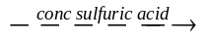C₂H₄ + H₂O

(b) The dissociation of nitrosyl chloride into nitric oxide and chlorine takes place
according to the equation:

2 NOCl (g) D 2 NO (g) + Cl₂ (g)

Varying amounts of the three gases were placed in a container and allowed to
come to equilibrium at two different temperatures. The equilibrium
concentrations of the three gases obtained are tabulated below.

Temperature, ⁰C | Concentrations (mol L⁻¹)
Temperature, ⁰C | NOCl | NO | Cl₂
230 | 2.33 x 10⁻³ | 1.46 x 10⁻³ | 1.15 x 10⁻²
465 | 3.68 x 10⁻⁴ | 7.63 x 10⁻³ | 2.14 x 10⁻⁴

(i) Calculate the equilibrium constant K, for the reaction at 230⁰ C . Show
relevant working. 3

Criterion/Criteria | Mark
Correct K expression , correct answer with relevant working | 3
Correct K expression and correct answer with no relevant working | 2
Correct K expression or correct answer with no relevant working | 1

Sample answer:

K = 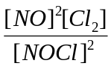
= 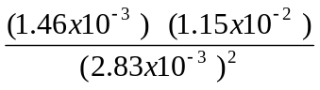

K = 4.52 x 10⁻³

(ii) The equilibrium constant at 465 ⁰C is 9.20 x 10⁻². Does the different
value for the equilibrium constant indicate that the reaction is
endothermic or exothermic? Explain your answer.

Criterion/Criteria | Mark(s)
Endothermic and correct explanation for variation in K | 2
Endothermic | 1

(iii) The energy change involved in the above reaction is 38kJ per mole
of nitrosyl chloride decomposed. Rewrite the equation for the
dissociation of one mole of nitrosyl chloride and complete the
description of the reaction by specifying ΔH (sign and magnitude)
for the reaction you have written.

Criterion/Criteria | Mark(s)
Correct equation with ΔH included | 1

( c) Describe two potential environmental issues associated with the extraction of
sulfur from mineral deposits. 2

Sample Answer:

Sulfur is easily oxidised to SO₂ or reduced to H₂S – both are serious air pollutants.
Water used may have dissolved impurities in the deposit and needs to be re-used
not discharged into the environment. Earth subsidence is possible as it is difficult
to backfill with this mining method (Frasch). Thermal pollution can result from
superheated steam released into local waterways..

(d) Describe the reactant conditions necessary for the production of SO₃ from SO₂. 3

Criterion/Criteria | Mark(s)
correct catalyst, temperature range and pressure | 3
2 correct of catalyst or temperature range or pressure | 2
correct catalyst or temperature range or pressure | 1

Sample answer:
Reactant conditions necessary for the production of SO₂ to SO₃ include
porous pellets of vanadium (V) oxide, V₂O₅ as a catalyst; 400 – 600 ⁰C
for a good yield at a reasonable rate and 1-2 atm of pressure as high
yields are obtained without the need of high pressure

(e) Explain the difference between galvanic cells and electrolytic cells in terms
of energy requiremnt.

Sample Answer:

A galvanic cell is one in which stored chemical energy is converted into electrical
energy – energy is spontaneously liberated. In an electrolytic cell – electrical
energy is supplied (or added) to cause a chemical change.

(f) (i) Write the full formulae equation for the production of sodium hydroxide
from sodium chloride. 1

Criterion/Criteria | Mark(s)
correct equation, no states required | 1

2 NaCl (aq) + 2H₂O(l) → 2 NaOH (aq) + Cl₂(g) + H₂(g)

(ii) The membrane process is one electrolytic method used to extract sodium
hydroxide from sodium chloride. Describe the membrane process and
explain, in terms of environmental considerations, why it is the industrially
preferred method of extraction.

Criterion/Criteria | Mark(s)
2 environmental considerations 2  composition of the membrane 1  function of the membrane 1  anode and cathode correct/ solutions or electrodes 1 | 5
4 of the above | 4
3 of the above | 3
2 of the above | 2
1 of the above | 1

Sample Answer:
In the membrane process of electrolysis used to extract sodium hydroxide,
the anode is titanium and sodium chloride flows through the anode
compartment. The cathode is steel mesh and water flows through the cathode
compartment. The anode and cathode are separated by a water – impermeable
membrane made from synthetic polymers such as Teflon. The special
membrane allows sodium ion to pass but not hydroxide or chloride ions.
This prevents the contamination of the sodium hydroxide. This method is
rapidly replacing the mercury and diaphragm processes. It produces a
much purer solution. Asbestos, which is a known carcinogen, is used
in the diaphragm process.. A problem associated with the mercury process
includes possible loss from the process, to the environment, of mercury which can be
toxic.

END OF TEST

